

Year 1/2 Newsletter

Term 2 2026


Team Update
Ruby Findlay has been appointed as the classroom teacher for 1/2E for the remainder of the year. You may recognise her from TeamKids. Welcome to the Year 1/2 Team,
Ruby!
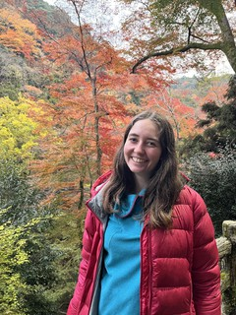




A reminder that our new whole-school timetable for 2026 is as follows:


Soft Start: 8.40am - students may enter the classroom when they hear the music Session 1: 8:50am to 9:40am
Session 2: 9:40am to 10:30am Recess: 10:30am to 11:00am Session 3: 11:00am to 11:50am Session 4: 11:50am to 12:40pm
Lunch Eating (inside): 12:40pm to 12:55pm Lunch Break (outside): 12:55pm to 1:40pm Session 5: 1:40pm to 2:30pm

Session 6: 2:30pm 3:20pm

Important Dates

Book Fair - 27th April - 1st May
Mother’s Day Breakfast - Friday 8th May
National Simultaneous Storytime - Wednesday 27th May
King’s Birthday Public Holiday - Monday 8th June
Last Day Term 2 - Friday 26th June First Day of Term 3 - Monday 13th July


Homework

Sounds-Write


Each Friday, students will be provided with a new Sounds-Write word list. The words will contain the sound and spellings that students have learnt about that week. Please help your child complete the activities that are outlined in the grid at the front of the book.

Please ensure your child returns their homework book each Friday so that their work can be celebrated and a new sheet can be pasted in.

Take-Home Reading

Each Friday, students will also change their take-home reading books. Year 1/2 students are expected to read for at least 10–15 minutes each day. Please remember to record your child’s daily reading in the yellow Reading Log Book and return these to school each Friday.





Mathletics and Reading Eggs are also available for your child to use at home.





LITERACY

READING
This term in Reading, students will read and listen to a variety of texts, with a focus on:
Non-Fiction Texts: understanding the purpose of non-fiction texts, and identifying and using their common features


Main Idea: identifying the main idea of a text (most important point)
Synthesising: identifying information in a text that is new and combining this new information with what we already know
Comparing and Contrasting: comparing two texts and noticing the similarities and differences (e.g. comparing text type, information provided, plots, characters, settings etc.)

WRITING
In Term Two, Year 1/2 students will learn about the structure, vocabulary and text features associated with Information Reports.

Students will practise taking notes on a variety of subjects and create labelled diagrams to support their writing.

Students will practise following the writing process (planning, drafting, editing, revising and publishing) and will publish the writing pieces they are most proud of.

Students will continue to embrace their creativity when writing in their personalised Writer’s Notebooks. They will use writing ‘seeds’ to spark ideas for their writing.

SOUNDS-WRITE

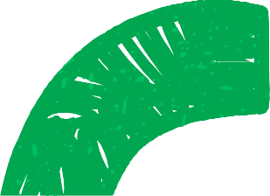
Each morning, Year 1/2 students will continue to participate in ‘Sounds-Write’ sessions, our school’s phonics program. Students will be introduced to new sounds from the ‘Extended Code’. They will practise blending sounds to read words, and manipulating sounds to build new words to read and spell. They will identify spellings in passages, practise reading and spelling high-frequency words, and work on letter formation. Students will be grouped into Year 1s and Year 2s for this session.

MATHEMATICS
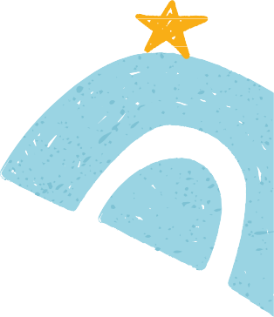
In Term 2, Year 1/2 students will be focussing on:

Addition and Subtraction
- using a variety of strategies to solve addition and subtraction problems. Strategies may include physical modelling and various mental calculations.

- number bonds to 20; exploring how numbers are related, how whole numbers can be broken into different parts, and how smaller numbers can be combined to make a whole

Time and Duration
- recognising and reading the time represented on an analog clock to the hour, half-hour and quarter hour

- describing the duration and sequence of events using years, months, weeks, days and hours

2D Shape
- making, comparing and classifying two-dimensional shapes
- describing shapes by referencing the number of sides and using spatial terms such as ‘opposite’, ‘parallel’, ‘curved’ and ‘straight’

INQUIRY
Our Inquiry theme this term is ‘Places and Spaces’. Students will explore the places in which they live,
why their places are important to them, the features
of places, and how places can be looked after.

We will explore our local community, including the important services and people within the community.
They will also consider ways to stay safe in our community.

Students will develop a curiosity about the design of a community and how the community's needs and safety are important considerations when planning and designing new places and spaces.

The Year 1/2 cohort will have many opportunities to interact with local spaces and people.

